## **Summary:**

# Data formats in practice

When you think about the word "format," a lot of things might come to mind. Think of an advertisement for your favorite store. You might find it in the form of a print ad, a billboard, or even a commercial. The information is presented in the format that works best for you to take it in. The format of a dataset is a lot like that, and choosing the right format will help you manage and use your data in the best way possible.

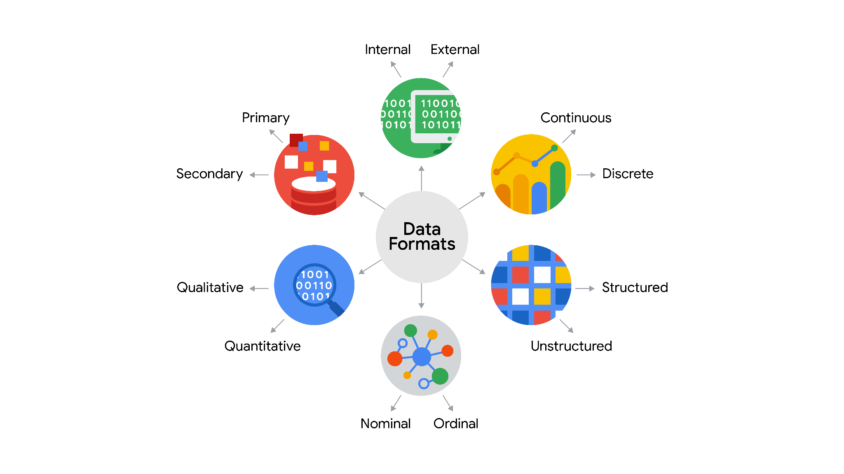

## **Structured data**

As we described earlier, **structured data** is organized in a certain format. This makes it easier to store and query for business needs. If the data is exported, the structure goes along with the data.

## **Unstructured data**

**Unstructured data** can’t be organized in any easily identifiable manner. And there is much more unstructured than structured data in the world. Video and audio files, text files, social media content, satellite imagery, presentations, PDF files, open-ended survey responses, and websites all qualify as types of unstructured data.

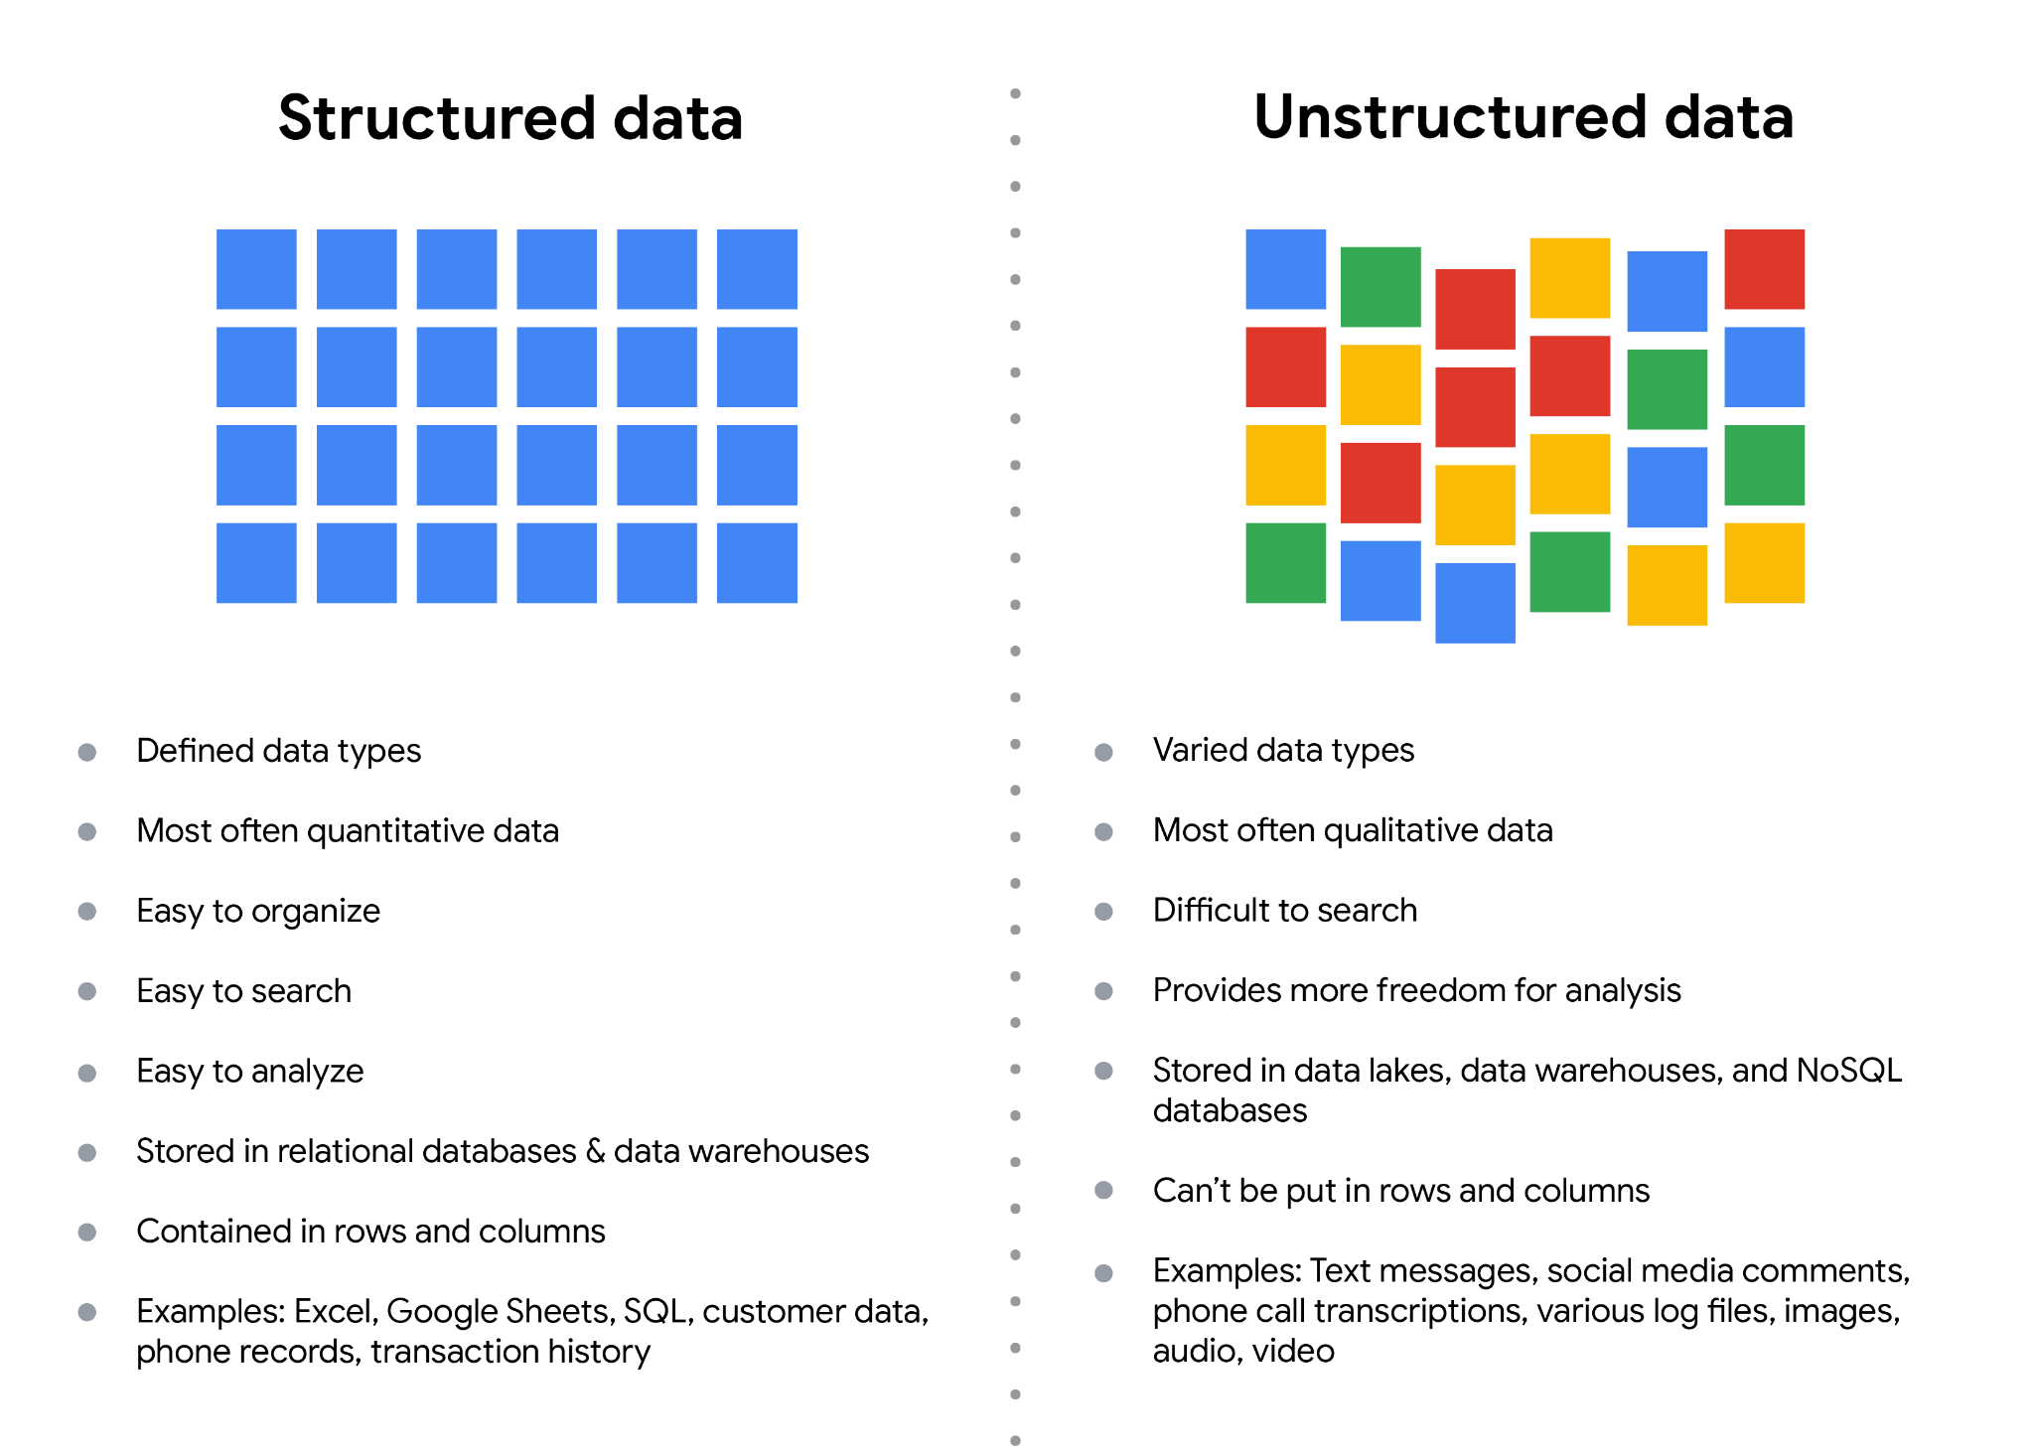

## **Data-modeling techniques**

**Data modeling** is the process of creating diagrams that visually represent how data is organized and structured. These visual representations are called **data models**.

There are a lot of approaches when it comes to developing data models, but two common methods are the **Entity Relationship Diagram (ERD)** and the **Unified Modeling Language (UML)** diagram. ERDs are a visual way to understand the relationship between entities in the data model. UML diagrams are very detailed diagrams that describe the structure of a system by showing the system's entities, attributes, operations, and their relationships..

You can read more about ERD, UML, and data dictionaries in this [data modeling techniques article](https://dataedo.com/blog/basic-data-modeling-techniques).

## **Data analysis and data modeling**

Data modeling can help you explore the high-level details of your data and how it is related across the organization’s information systems. Data modeling sometimes requires data analysis to understand how the data is put together; that way, you know how to map the data. And finally, data models make it easier for everyone in your organization to understand and collaborate with you on your data. This is important for you and everyone on your team!

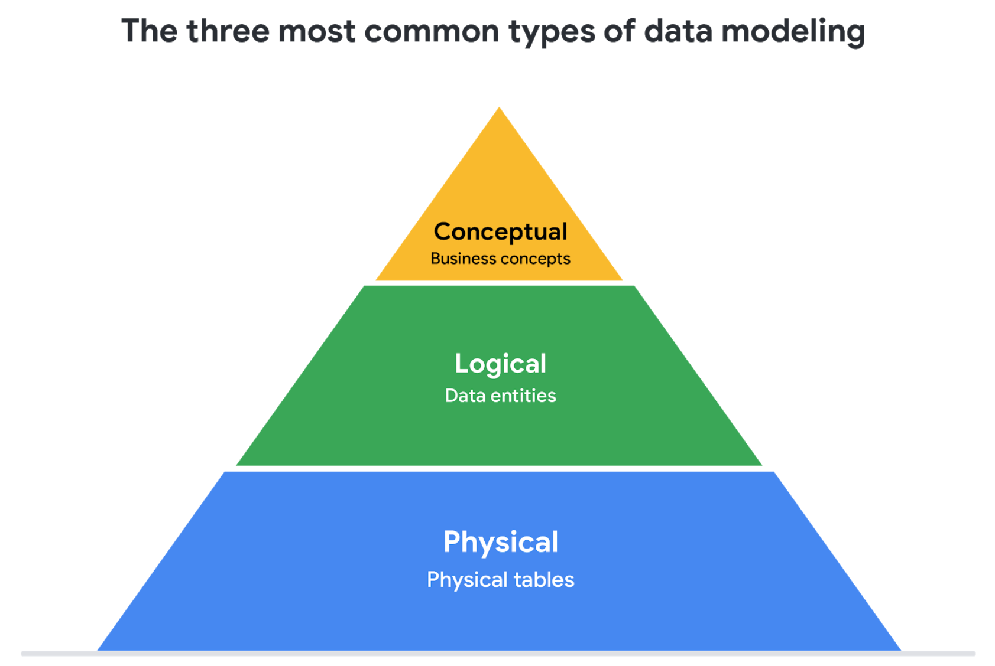

1. **Conceptual data modeling** gives a high-level view of the data structure, such as how data interacts across an organization. For example, a conceptual data model may be used to define the business requirements for a new database. A conceptual data model doesn't contain technical details.
2. **Logical data modeling** focuses on the technical details of a database such as relationships, attributes, and entities. For example, a logical data model defines how individual records are uniquely identified in a database. But it doesn't spell out actual names of database tables. That's the job of a physical data model.
3. **Physical data modeling** depicts how a database operates. A physical data model defines all entities and attributes used; for example, it includes table names, column names, and data types for the database.

**Quiz:**

* Fill in the blank: The running time of a movie is an example of _____ data : ***Continuous***
* What are the characteristics of unstructured data? Select all that apply : ***Is not organized, May have an internal structure***
* Structured data enables data to be grouped together to form relations. This makes it easier for analysts to do what with the data? Select all that apply ***Store; Search, Analyze***
* Which of the following is an example of unstructured data : ***Email message***

### 